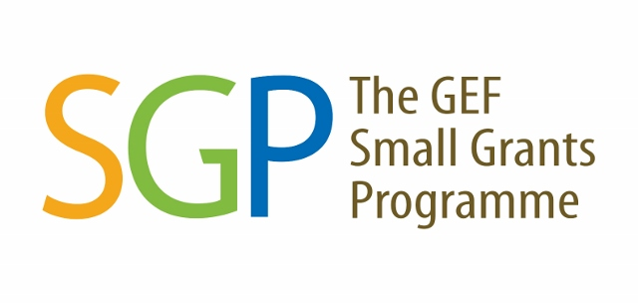

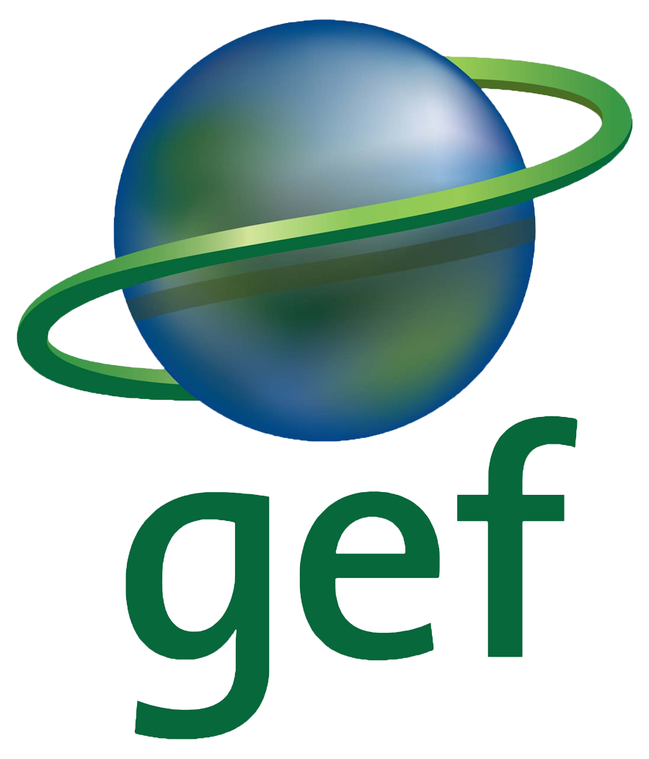

THE GEF SMALL GRANTS PROGRAMME

CONCEPT PROPOSAL Template (ver. 01/19)

Youth & Climate Innovation Programme

Note: The purpose of the concept proposal is to help the NC to determine that the proposed project idea and status of applicants are in conformity, from the beginning, with the GEF focal areas, global SGP and country programme’s guidelines and operating procedures.

IMPORTANT: Please refer to the Guidance Notes when filling up this template

Project Title:
Expected Project Duration: (month/s):
(12 – 18 months)
Project Location(s):
Name of Organization:
(Please Provide Organisation Registration Certificate)
Date Established:
No. of Staff/members:
Correspondence Address:
Name of Applicant:
Position:
Office Telephone:
Mobile:
Email:

Thematic Area (choose one) |  |  | Project Characteristics  (choose at least one)
( )Theme 1: “Green jobs” for young generation  ( ) Theme 2: Develop awareness, skills and competencies of young people to lead climate action on local, national and global levels. |  |  | ( ) Emphasis on sustainable livelihoods  ( ) Significant participation of indigenous peoples  ( ) Policy impact  ( ) Pilot project  ( ) Capacity building  ( ) Gender equality  ( ) Women’s empowerment  ( ) Persons with disabilities  ( ) I nnovative financial mechanisms  ( ) Others: ______________________ (pls specify)

Organisation capacity and any previous experience in undertaking similar projects with youth.

Explain in detail the bold, innovative and transformative of your proposed ideas (you may use photographs and any other supporting materials to illustrate the ideas).

Project location and target group (describe briefly project location or area and the envisaged involvement of youth in the project).

Overall objectives of the project

Planned activities (briefly list down all planned activities and how the target group or youth will be engaged)

Expected result/outcomes (describe what are the expected outcomes from the project and potential for replication and scaling up)
Project Outcomes

Potential for Replication and Scaling Up

Have your organization ever received grants from GEF or other organizations? (list down the amount and funder for the past two years)

Please provide main partners and their roles for this project? If you required assistance for finding project partners or technical experts in the implementation of the project, please specify.

Please provide rough budget estimation according to your planned activities (in Ringgit). Maximum RM200,000.
- Administration (not more than 15% of the GEF-SGP fund requested):
  - –
  - –
  - –

- Activities
  - –
  - –
  - –
  - –
  - -
- Equipments & Materials
  - –
  - –
  - –

- Project Monitoring & Evaluation
- Documentation & publication

Please provide the possibilities for securing co-financing from other donors and the estimated amount.

- Supporting documents (MUST PROVIDE):

  - Organisation Registration Certificate
  - Organisation Chart
  - Organisation Bank Account Detail:

Account Holder Title
Account Number
Name of Bank
Address of Bank

A copy of letterhead of a recent bank statement with clear indication of account holder title, account number and name of bank should be attached here.

