


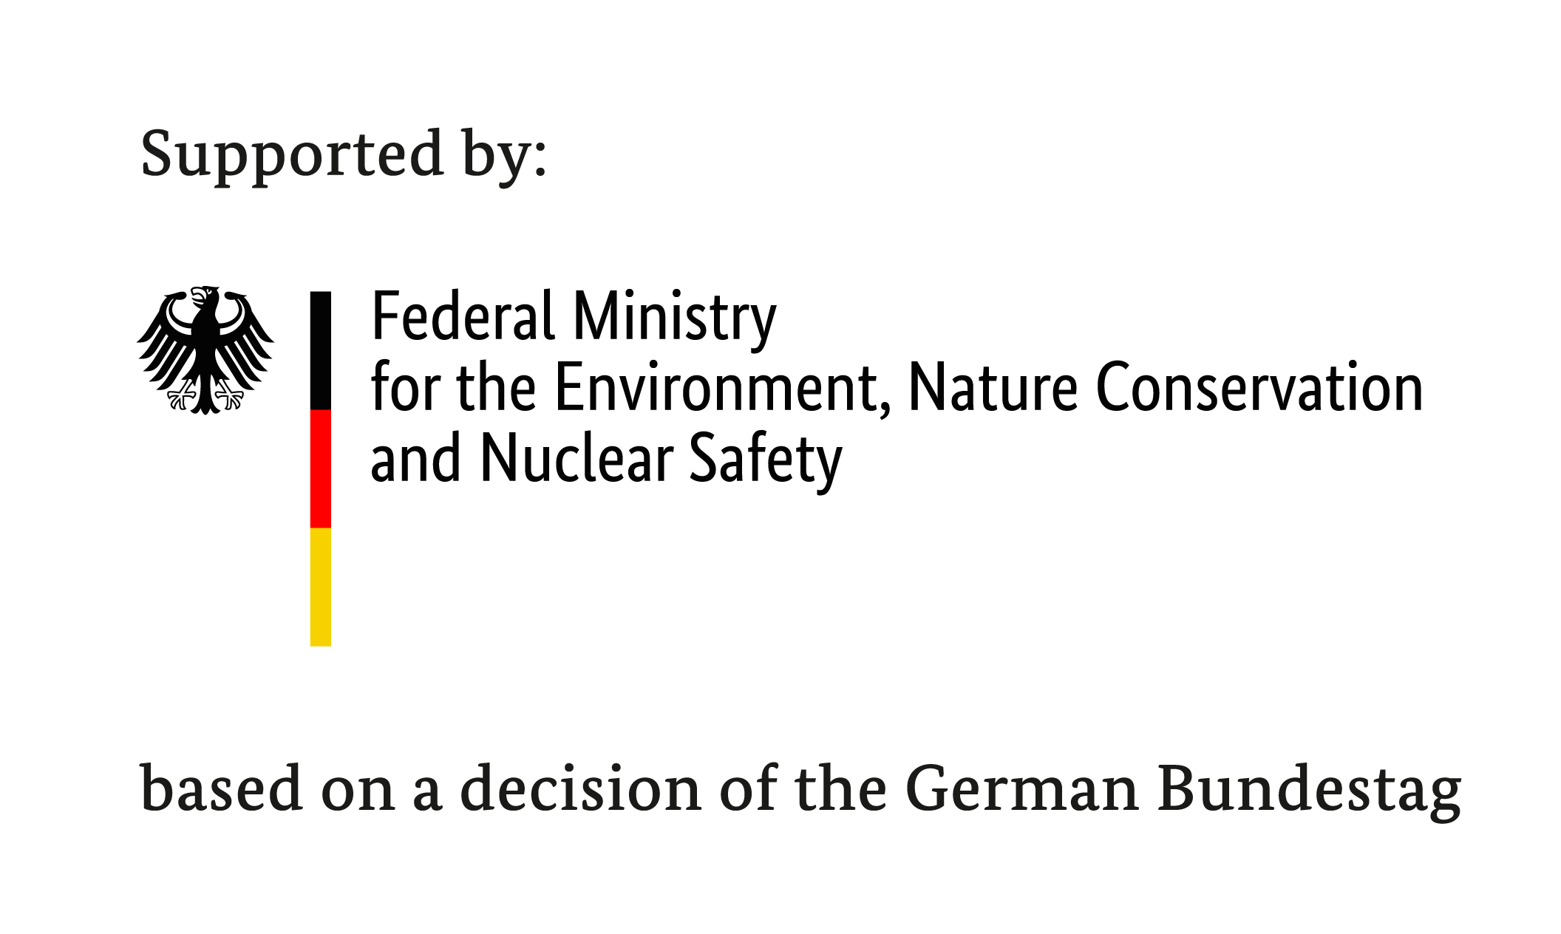

THE ICCA-GSI-GEF SMALL GRANTS PROGRAMME

CONCEPT PROPOSAL Template - ICCA (ver. 2020)
COVID-19 Support To Territories And Areas Conserved By Indigenous Peoples And Fishing Communities (ICCAs) In Malaysia

Project Title:
Expected Project Duration: (month/s):
maximum 18 months
Project Location(s):
Name of Organization:
(Please Provide Organisation Registration Certificate)
Date Established:
No. of Staff/members:
Correspondence Address:
Name of Applicant:
Position:
Office Telephone:
Mobile:
Email:

Thematic categories for ICCA-GSI projects in response to COVID 19 (You are encouraged to integrate few thematic categories in this proposal)
Communication and lessons sharing through culturally appropriate means | Translating and communicating medical and sanitary information on COVID-19 into local and vernacular languages.
Food production systems: agroecology and agroforestry | Strengthening sustainable and biodiversity-friendly food production systems in ICCAs focused on agroecology and agroforestry techniques.
Sustainable and well governed wildlife consumption | Promotion of sustainable and regulated wildlife consumption through good governance, customary regulation, and awareness raising.
Prevention of zoonoses and future pandemics | Strengthening of ICCAs to provide barriers for zoonotic disease transmission and habitat conservation through reduced fragmentation.
Transmission of traditional medical knowledge | Documentation and transmission of sustainable techniques for harvesting, quality control, and transmission of traditional medicinal practices.
Territorial mapping and demarcation for self-isolation and conservation | Mapping and demarcation to increase territorial zoning, self-isolation procedures, buffer zones and defence of conserved areas.
Local bio-circular economy approaches based on reciprocity | Income-generation activities, reciprocal food exchange networks, community-based ecotourism-based ventures, provision of food to at-risk populations, locally-made personal protective equipment.

Provide organisation capacity and any previous experience in (i)community-based conservation; ii) facilitation of networks and joint learning; iii) monitoring and evaluation of conservations and/or governance initiatives; and (iv) capacity to work with spatial and monitoring data.

Explain in detail the challenges faced by local community and how this project able to strengthen their short-term coping mechanisms as well as their long-term socio-ecological resilience (you may use photographs and any other supporting materials to illustrate the problems/issues)

Project location and target group (describe briefly project location or specific ICCA or group of ICCAs and the involvement of indigenous people and fishing community in the project).

Overall objectives of the project

Planned activities (briefly list down all planned activities to respond to the COVID-19 pandemic and how the indigenous people or fishing community will be engaged and benefits from the activities)

Expected result/outcomes (describe what are the expected outcomes from the project).

Have your organization ever received grants from other organizations? (list down the amount and funder for the past three years)

Please provide main partnerships to strengthen the ICCAs and their roles for this project?

Please provide rough budget estimation according to your planned activities (in Ringgit). Not more than RM200,000.
- Administration (not more than 15% of the GEF-SGP fund requested):
  - –
  - –
  - –

- Activities
  - –
  - –
  - –
  - –
  - -
- Equipments & Materials
  - –
  - –
  - –

- Project Monitoring & Evaluation
- Documentation & publication

Please provide the possibilities for securing co-financing from other donors and the estimated amount.

- Supporting documents (MUST PROVIDE):

  - Organisation Registration Certificate
  - Organisation Chart
  - Organisation Bank Account Detail:

Account Holder Title
Account Number
Name of Bank
Address of Bank

A copy of letterhead of a recent bank statement with clear indication of account holder title, account number and name of bank should be attached here.

